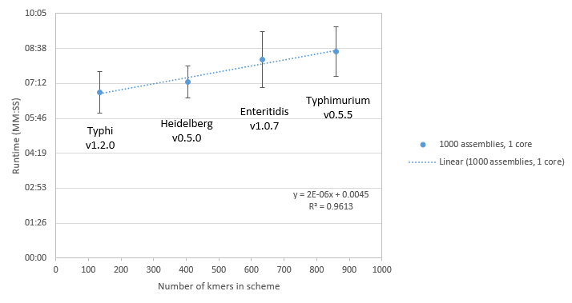

Figure S3. BioHansel runtime per 1000 genome assemblies on one core using different schemes in a high performance computer cluster environment.  Each data point represents an average of at least 8 experiments for each serovar.